VR Critiques Pt 1

DIG 4633C

Dexavier Williams

9/3/2019

**Oculus First Contact**

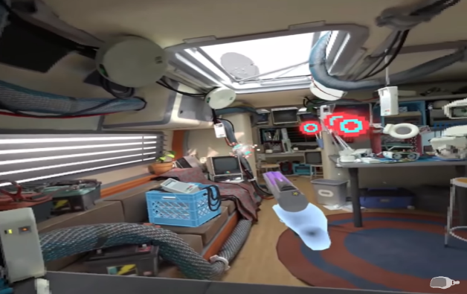

This experience consisted of me trying out the cartridges that the robot would give me. Some cartridges offered me items to play around with while others created simulations. It was incredibly fun to throw the cartridges at the robot. The experience felt nice as it was interesting to see what each cartridge would do. The Oculus First Contact was released on December 5, 2016 and meant to be an introduction to the Oculus Touch technology. Based on my experience and the official website, I would say that the realm of science fiction played a huge factor in its overall creation.

Finding common themes was slightly harder for this game as the experience is very short. I found themes of human interaction, friendship, and discovery. The theme of friendship and human interaction are heavily stressed as you play through the game. Your new android buddy gives you things to do and as you do them you guys form a bond. I say discovery because as the player you are trying to figure out what needs to be done next. As stated earlier you go through cartridge after cartridge trying to test out the functions of each, you do this until you reach the golden one.

As an over-simplistic game, Oculus has no real weaknesses when it comes to virtual reality technology. The game is easy to play, and everything is explained thoroughly. There was nothing difficult about learning the controls. All the elements from the characters to picking things up went just fine. The only real weakness of this is that it doesn’t really fill like an experience. Once I won the target shooting game everything just ended abruptly. I never felt like I had a genuine virtual reality experience. I wish the demo would have been slightly longer as I completed it rather quickly.

**Virtual Virtual Reality**

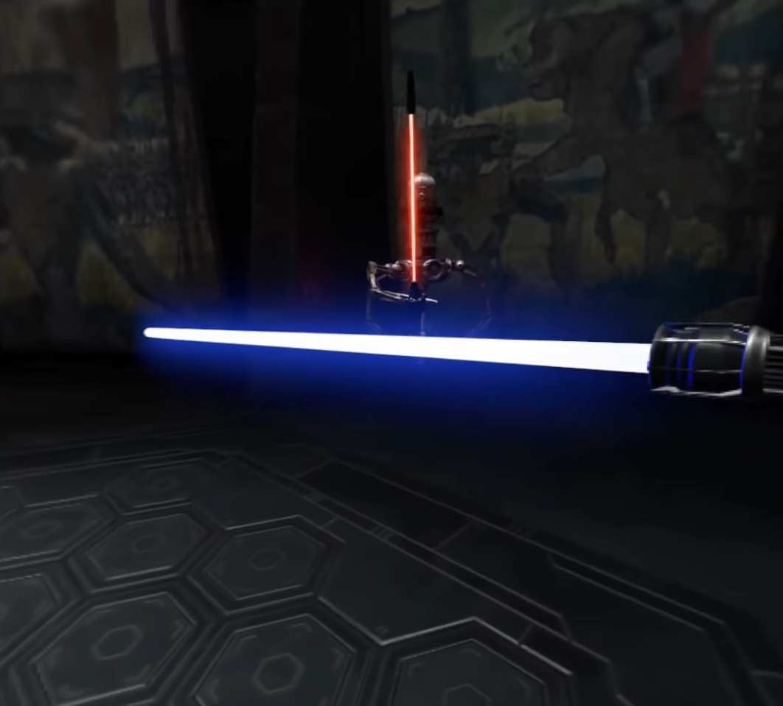

The first client I interacted with was a piece of butter named Butter. This took place in a kitchen, and I was constantly ordered to feed him well-done toast. I failed this objective and would be forced to vacuum the mess and go back to the testing lab. This experience was released in March 2017 and was designed for several virtual reality headsets. I took the experience rather well as each client I worked for had a different personality and objective than the last. It appears that the movie Wall-E had an influence on this game as their stories are identical. You have a robotic helper whose sole purpose is to cater to their owner.

The themes that I selected from reviews and myself are exploration, the unknown, and servitude. To me, the theme of exploration and the unknown go hand in hand. You can meet new clients and cater to them. Each client is different than the last and allows for creative ways to adventure through the game. The unknown is like the exploration theme as you genuinely know nothing about your client until you reach them. Servitude was the one I came up with as you appear to be nothing but a slave. You’re only programmed to do with your owners want and if you fail then you’re punished. You don’t have free will and must stay in the boundaries of what is allowed.

Throughout my play session, I was unable to find any weaknesses. Everything was able to work with the technology completely fine. I never encountered any problems while I was learning the mechanics of the game. When I was instructed to pick items up, put items down, throw items and do any other tasks my clients wanted they were easily done. The fact that each client offered a familiar way to use the controls made playing this game a rewarding experience. Virtual Virtual Reality took full advantage of the technology and in my opinion, successfully made the game an interesting experience.

**Vader Immortal: Episode 1**

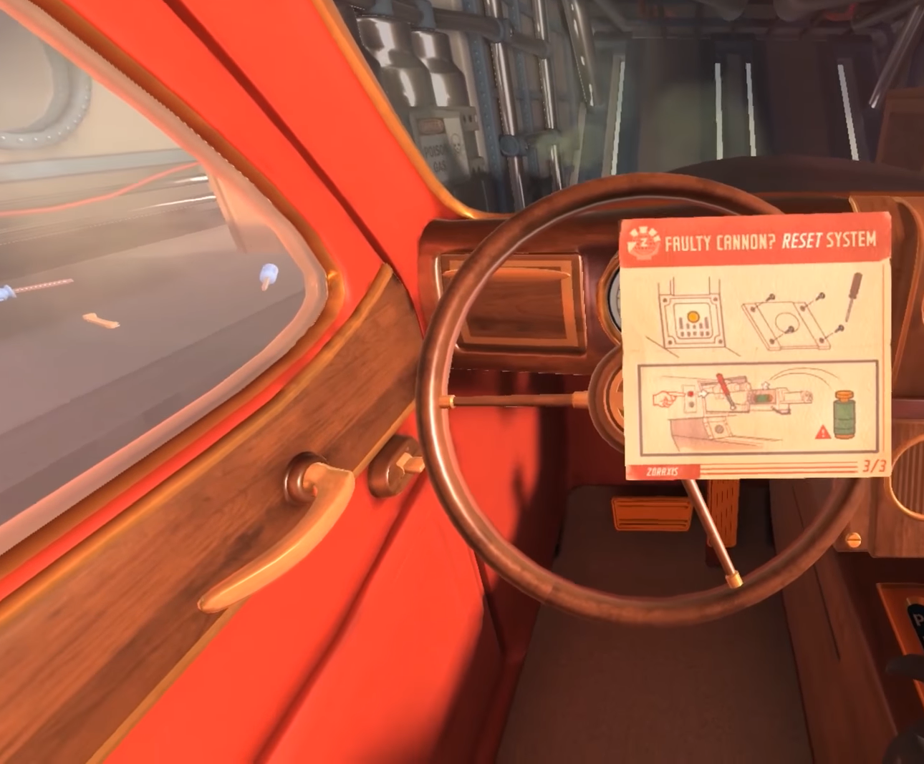

The best interaction I had was the lightsaber duel with the android. I enjoyed this experience out of them all because it placed me at the forefront of the series. Action was always the selling point, so I couldn’t wait to experience it in real time. The duel was simple you follow the movements on screen and try your best to match up with them. There’s a certain amount of discipline required as you can’t randomly flail your lightsaber to win a match. This experience was released this year in May for the Quest and Rift platforms. The Star Wars franchise is the obvious influence for this game and there are gadgets and characters that are borrowed.

From reading the reviews and my own observations, I was able to pick power, good vs evil and teamwork as common themes of the game. Power is the most obvious as it explains Vader’s intention for kidnapping you and your teammate and it is what sets the game's events in place. Coming in second is good vs evil which is one of the oldest themes used in media. Your main character is the good guy who wants to escape the evil Sith Lord’s ship in one piece. The two previous themes lead to the last one I noticed which was teamwork. Throughout the game, you encounter several hurdles that require you to work with your android sidekick. You two both need each other, and this is heavily stressed as you run into one enemy after another.

Like the previous two experiences, this one worked well with virtual reality. Unlike the first two, I’m able to add on more strengths. The other strengths happened when I was able to perform multiple different things and the technology was still capable of working. Everything from free climbing the pipes to the lightsaber battle with the android felt realistic. I enjoyed the fact that they set you into the Star Wars story and allow you to utilize items from the film. Even though I enjoyed this experience, I couldn’t help but get dizzy from the different movements that it required.

**I Expect You To Die**

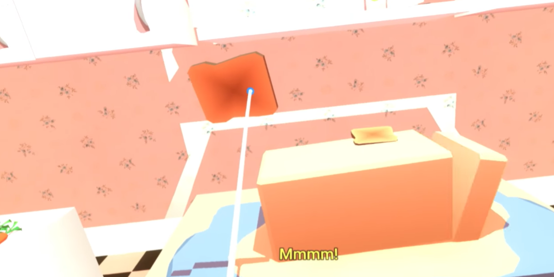

For my playthrough, I decided to try the car bomb mission titled Friendly Skies. Because I really wanted to beat this mission this ended up being the only one I tried. I spent minute after minute trying to piece together how to get out of the plane until I decided to just give up from tiredness. I enjoyed the experience because it was something new and fresh and mixed in with the humorous narrator made it worthwhile. Once I realized I couldn’t beat the mission, I just decided to find a new way to die instead. This experience was released in December of 2016 for five different virtual reality platforms. From the looks of it, the aesthetic and feel are influenced by a mixture of classic spy films and three-dimensional animation.

The three themes I found for my last experience were adventure, danger, and sacrifice. Even though I never did any other missions I am aware that there are several more located in the game. That is where the adventure theme comes from as each mission presented will require a different objective. As a spy you several options on how you want to play the game which creates a sense of adventure for the player. The theme of danger is located throughout the whole game except for the introduction class. You have that sense of danger since you are always at a point of where you could die. Sacrifice was the theme that I picked myself. I state this as a theme because it correlates with what happens in the game. You must indirectly sacrifice your lives to be able to get better at the game.

There were no weaknesses when I played, I Expect You To Die. When I was required to perform a certain task, it always made sure I knew how the controls worked. I can say this game is suited for virtual reality use. The mechanics worked rather well and as I played more, I started to get the hang of it. All things considered, each of the games were able to work well. I encountered very few problems throughout each of my play sessions. The problems that I did encounter were related to dizziness from prolonged play periods, not the headset being unable to work.